AEGIS OVERSEAS
Scholarships Tab — UI & Data Specification
Implementation brief for a frontend-only React/Vite website

1. Purpose and source-of-truth rules
Build the Scholarships section as a static, informative scholarship directory for Aegis Overseas. Use the attached UI image as a visual reference, but use this document—not tiny text rendered inside the image—as the source of truth.
- This is a static frontend. Do not add a backend, database, scheduled jobs, scraping, or live API dependency.
- Dates and award terms can become outdated. Store the academic cycle and verification note with every scholarship.
- Never claim a future opening date or deadline is confirmed unless the official scholarship provider has published it.
- When the next cycle is not announced, display “Next call to be announced” or “Check official website”; do not infer that it opens on the same date every year.
- Use status labels carefully: Closed (displayed cycle deadline passed), Upcoming (confirmed future window), Open (officially confirmed active window), Check official call (dates not verified), Discontinued (programme no longer accepts applications).
- Every record should have an official source URL and last-verified date. Do not describe an award as an Aegis partner award unless documented.
- Scholarship selection is competitive. Never promise admission, scholarship selection, visa approval, a job, or permanent residency.

2. Visual reference
The reference image shows four connected experiences: (1) scholarship listing page, (2) scholarship detail page, (3) Eligibility & Guide panel, and (4) Check Eligibility / consultation form.
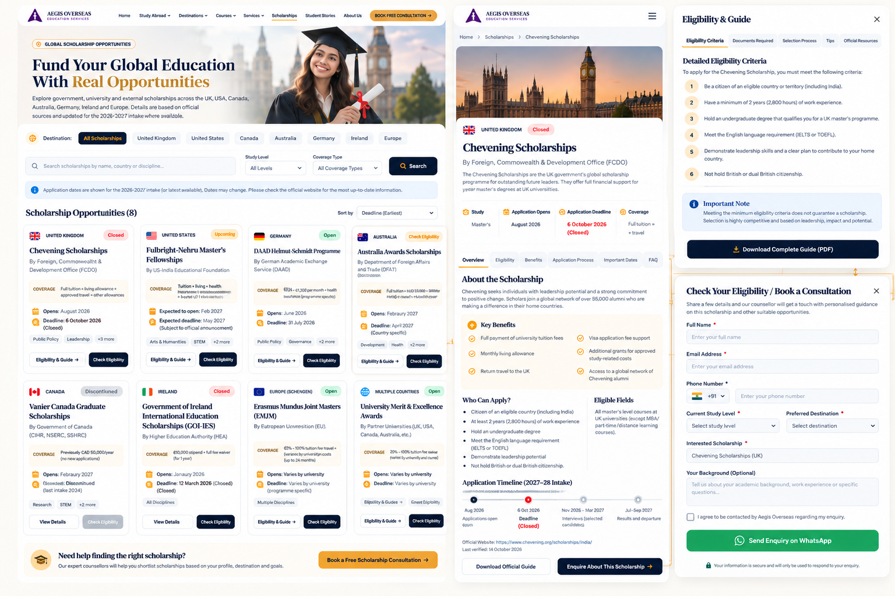

3. Design system and listing page
- Keep the existing Aegis navigation and brand: cream/white background, navy text, gold accents, serif display headings, sans-serif body, rounded cards, subtle borders/shadows.
- Desktop: 3–4 cards per row depending on width; tablet: 2 columns; mobile: 1 column. Avoid horizontal overflow.
- Hero heading: “Fund Your Global Education With Real Opportunities”. Avoid unsupported claims such as “$14.5M+ secured”, “1200+ partner universities”, “100% full-ride awards available”, or “verified” unless Aegis can substantiate them.
- Suggested hero notice: “Scholarship terms, eligibility and deadlines vary by provider, institution, course and intake. Always confirm details with the official source.”
- Filters: destination, study level, coverage type, and search by scholarship name/country/discipline. Sort by deadline only where a verified date exists.
- Each card: country, provider, scholarship name, status, level, opening date/month, deadline date/month or an explicit unknown label, coverage summary, eligibility tags, Eligibility & Guide, Check Eligibility, official source.

4. Correct interaction flow

A. Eligibility & Guide
- Open a side drawer or detail page for the selected scholarship; do not send the user straight to the generic contact form.
- Include Overview, Eligibility Criteria, Documents Required, Benefits & Coverage, Application Steps, Dates & Status, FAQs, and Official Links.
- Show scholarship-specific criteria only when supported by its official source. Mark unverified details as “Confirm on official website”.
- Include a note that meeting minimum criteria does not guarantee selection.
- Provide “Visit Official Website” and “Ask Aegis for Guidance” actions.

B. Check Eligibility / consultation form
Open a modal or drawer with these fields:
- Full name (required)
- Email address (required)
- Phone number with country code (required)
- Current study level (required): Undergraduate, Master’s, PhD/Research, Other
- Preferred destination (required)
- Interested scholarship (pre-filled from selected card; editable)
- Academic background / work experience / questions (optional)
- Consent checkbox for Aegis to contact the student (required)
On submit, prepare a prefilled WhatsApp enquiry using the existing approved Aegis WhatsApp number. Open WhatsApp with the message ready; do not claim the message was sent automatically. Suggested message: “Your enquiry is ready in WhatsApp. Please tap Send to share it with an Aegis advisor.”

5. Static scholarship data model
Keep dates, amounts, coverage and status as structured data rather than hard-coded UI strings.
type ScholarshipStatus =
| "open" | "upcoming" | "closed"
| "check_official_call" | "discontinued";
type Scholarship = {
id: string;
name: string;
countryLabel: string;
destinationId: string;
provider: string;
studyLevels: string[];
eligibleNationalities?: string[];
disciplines?: string[];
amount?: {
min?: number;
max?: number;
currency: string;
period?: "one_time" | "per_year" | "per_month" | "total" | "varies";
displayText: string;
};
coverage: string[];
openingDate?: string; // exact date only if officially published
openingMonthLabel?: string; // historical/typical only, label it clearly
deadlineDate?: string; // exact date only if officially published
deadlineMonthLabel?: string;
academicCycle: string; // e.g. "2026-27"
status: ScholarshipStatus;
statusNote: string;
officialSourceUrl: string;
lastVerifiedDate: string;
verificationNote: string;
};

6. Scholarship records: recommended publication status
These are conservative content recommendations based on research available for this brief. Treat this as a starting dataset; verify each official page before production. Do not present all records as currently open.
Scholarship | Destination | Status / date guidance | Coverage summary | Official source
Chevening Scholarships | United Kingdom | Closed for 2027–28  Opening: August 2026; deadline: 6 October 2026 | Full tuition; living allowance; eligible travel and other allowances under official terms | https://www.chevening.org/scholarship/india/
Fulbright-Nehru Master's Fellowships | United States | Check next official call  Do not publish new cycle dates until USIEF confirms them | Tuition/fees and support specified in current official award terms; no unsourced total dollar estimate | https://www.usief.org.in/
DAAD Helmut-Schmidt Programme | Germany | Check exact programme call  Use dates from the specific Helmut-Schmidt call; do not reuse dates from another DAAD award | Stipend and eligible allowances per the specific programme call; verify amount and benefits | https://www.daad.de/en/studying-in-germany/scholarships/
Australia Awards Scholarships | Australia | Check country eligibility  Country-specific window; do not assume Indian applicants are eligible | Tuition, living and other eligible benefits only where the applicant and programme qualify | https://www.dfat.gov.au/people-to-people/australia-awards/participating-countries
Vanier Canada Graduate Scholarships | Canada | Discontinued  No active application window | Do not present old CAD $50,000/year as active; replace with a current doctoral award only after verification | https://vanier.gc.ca/en/home-accueil.html
Government of Ireland International Education Scholarships (GOI-IES) | Ireland | Closed for 2026 call  Opened 29 January 2026; deadline 12 March 2026 | €10,000 stipend for one year plus host-institution full fee waiver for that scholarship year, under 2026 call terms | https://hea.ie/policy/internationalisation/goi-ies/
GREAT Scholarships | United Kingdom | Check university-specific deadline  Opening/deadline differ by participating university and country | For eligible 2026–27 India awards, at least £10,000 towards tuition; check each university listing | https://www.britishcouncil.in/study-uk/scholarships/great-scholarships
Erasmus Mundus Joint Masters | Europe / multiple countries | Check programme-specific call  Many deadlines fall around October–January, but each consortium publishes its own dates | Eligible scholarship may contribute to participation costs, travel, visa and living costs; programme terms apply | https://erasmus-plus.ec.europa.eu/opportunities
University Merit & Excellence Awards | Multiple countries | Not one scholarship  Split into named university records; deadlines vary | Do not publish a generic global amount; add named awards with official value and terms | Split into named awards
Vanier should not appear as an active award. Australia Awards should not be advertised as available to Indian applicants without checking official eligibility. For GREAT and university merit awards, deadlines and values must be tied to a specific participating university.

7. Amount and coverage display rules
- Prefer exact official values for named awards. State currency and period: per month, per year, one-time, or total.
- Country-wide ranges are not guaranteed amounts. If displaying indicative ranges, label them as examples from selected universities and link to each named award.
- Never add unrelated awards together or imply every university in a country offers the same value.
- For Chevening and GOI-IES, list confirmed benefits instead of inventing a total monetary value.
- If no reliable amount is available, show “Varies by university/programme”.
- Separate tuition, living stipend, travel, insurance, visa support and other allowances. Do not imply all are covered unless the official source says so.

8. Suggested static file structure
Use the existing project conventions; do not restructure unrelated code.
src/data/scholarships.ts
src/data/scholarshipTypes.ts
src/components/scholarships/ScholarshipCard.tsx
src/components/scholarships/EligibilityGuideDrawer.tsx
src/components/scholarships/EligibilityConsultationForm.tsx
Do not add an API, database, cron job, scraper, or third-party live feed.

9. Acceptance checklist
- A passed deadline never shows Open.
- Unknown future dates show “Next call to be announced” or “Check official website”, not a guessed month.
- Each amount includes currency and period or says it varies.
- Coverage categories are explicit: tuition, stipend/living, travel, insurance, visa support and other eligible allowances.
- Vanier is not active; Australia Awards eligibility is confirmed before being offered to Indian applicants.
- GREAT and university merit awards use university-specific deadlines.
- Eligibility & Guide opens scholarship-specific information, not only a generic form.
- Check Eligibility opens a form prefilled with the selected scholarship.
- WhatsApp requires the user to tap Send.
- Official source and last-verified date are visible on detail pages.
- Desktop, tablet and mobile layouts work without horizontal overflow.
- Existing navigation and unrelated pages remain unchanged.

10. Copy-paste prompt for the AI coding agent
Read this specification and inspect the existing Aegis Overseas React/Vite project before editing. Use the attached scholarship UI image as a visual reference only; this document is the source of truth for content rules.
Implement the Scholarships tab using static frontend data only. Do not add a backend, database, API, scheduled task, or live scraping. Preserve current navigation and unrelated functionality.
Build the scholarship listing cards, filters, accurate status labels, separate opening/deadline fields, structured coverage, scholarship detail page, Eligibility & Guide drawer, and Check Eligibility consultation form. Every record must have an official source URL, academic cycle, status note, and last-verified date.
Never guess future dates, award amounts, coverage, partner relationships, or eligibility. If a future call is not announced, show “Next call to be announced” or “Check official website”. If deadlines vary by university/programme, say so. A passed deadline must not show Open. Mark Vanier as discontinued and do not show it as an active scholarship. Verify Australia Awards eligibility for Indian applicants before presenting it as available.
Use the Aegis cream/white, navy and gold design. Eligibility & Guide opens scholarship-specific criteria, documents, benefits, steps, FAQs and official links. Check Eligibility opens a form prefilled with the selected scholarship. Submit prepares a WhatsApp message using the existing approved number; do not claim it was sent automatically.
After implementation, test filtering, date/status display, all CTAs, the form, mobile layout and external official links. Do not invent missing data; flag records needing manual verification.

11. Maintenance approach for a static website
A static site can still be trustworthy if someone manually reviews the official sources before each recruitment cycle. Use a visible “Last verified” date and honest “Check official call” statuses. If the next cycle has not been published, do not reuse last year's dates as confirmed future dates.

